Task – 1: Joins Practice (SQL)
Introduction
The objective of this task is to understand and implement different types of SQL joins to combine data meaningfully from multiple tables. This task focuses on INNER JOIN, LEFT JOIN, RIGHT JOIN, and FULL JOIN.

#Table 1: Students
DROP TABLE IF EXISTS Students;
CREATE TABLE Students (
student_id INT,
student_name VARCHAR(50),
branch VARCHAR(30)
);

#Table 2: Marks
DROP TABLE IF EXISTS Marks;
CREATE TABLE Marks (
mark_id INT,
student_id INT,
subject VARCHAR(30),
marks INT
);

#Insert data into Students
INSERT INTO Students VALUES
(1, 'Amit', 'E&TC'),
(2, 'Sneha', 'Computer'),
(3, 'Rahul', 'IT'),
(4, 'Priya', 'Mechanical'),
(5, 'Rohit', 'E&TC'),
(6, 'Neha', 'Civil'),
(7, 'Kiran', 'Electrical'),
(8, 'Anita', 'Computer'),
(9, 'Suresh', 'IT'),
(10, 'Meena', 'Mechanical');

select * from Students;
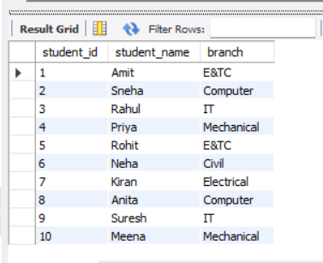

#Insert data into Marks
INSERT INTO Marks VALUES
(101, 1, 'Maths', 78),
(102, 2, 'DBMS', 85),
(103, 3, 'OS', 72),
(104, 1, 'Electronics', 80),
(105, 5, 'Signals', 75),
(106, 6, 'Survey', 68),
(107, 11, 'Maths', 60),
(108, 8, 'Java', 88),
(109, 9, 'Python', 90),
(110, 12, 'Physics', 70);

select * from Marks;
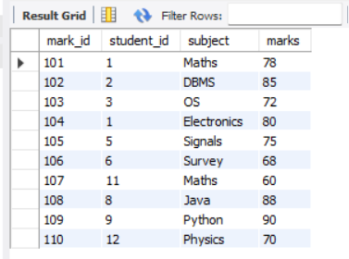

#Inner Join
SELECT S.student_id, S.student_name, M.subject, M.marks
FROM Students S
INNER JOIN Marks M
ON S.student_id = M.student_id;
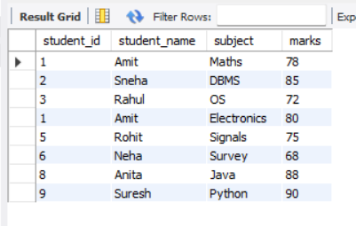

#Left Join
SELECT S.student_id, S.student_name, M.subject, M.marks
FROM Students S
LEFT JOIN Marks M
ON S.student_id = M.student_id;
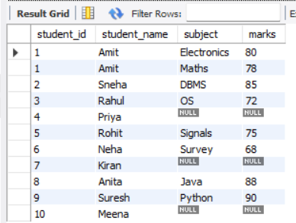

#Right Join
SELECT S.student_id, S.student_name, M.subject, M.marks
FROM Students S
RIGHT JOIN Marks M
ON S.student_id = M.student_id;
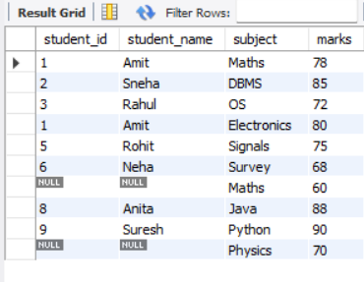

#Full Join
SELECT S.student_id,
S.student_name,
M.subject,
M.marks
FROM Students S
LEFT JOIN Marks M
ON S.student_id = M.student_id

UNION

SELECT S.student_id,
S.student_name,
M.subject,
M.marks
FROM Students S
RIGHT JOIN Marks M
ON S.student_id = M.student_id;
